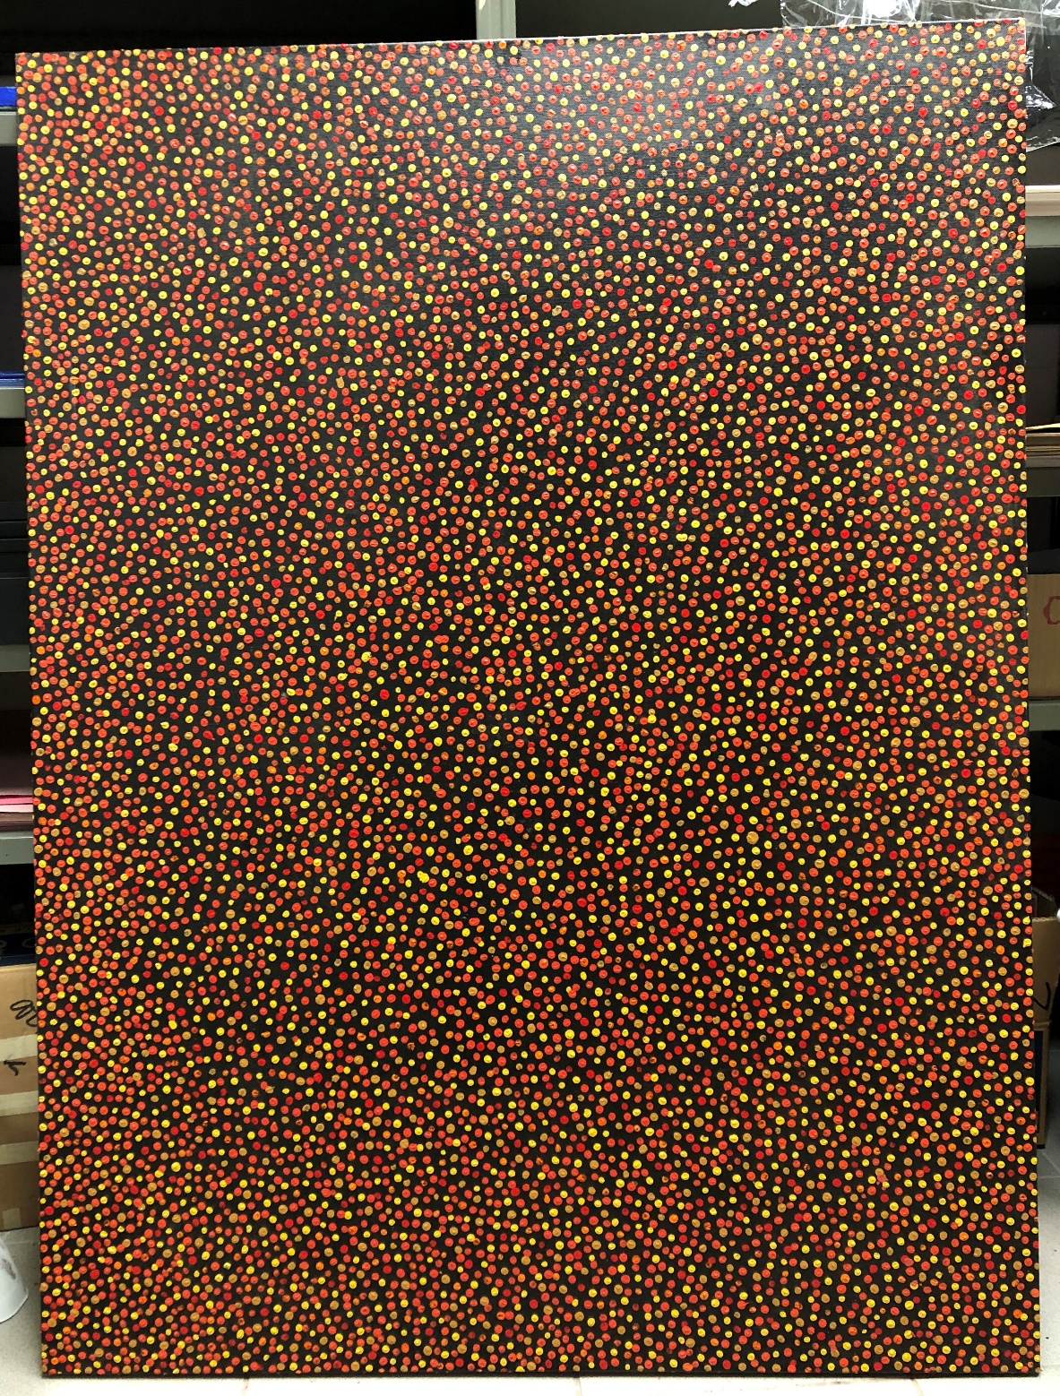
Waru
Canvas, house paint, acrylic paint, stick
March 4th, 2020

The purpose of this artwork was to show a representation of the Australian bush fires in the art style of the aboriginal Australian people.

